**Web Tech Assignment #1**

**Ihtisham Nadeem Chaudhry**

**Student ID: 40409062**

**Introduction**

Web Technology has been referred to as the adoption of the best web practices to create highest possible level of efficiency within a website. This website consist of taking the text from a user and provides the encoded text using one of the three ciphers, which have been implemented into the web design. On the home page you can see a small description about cryptography following are the three types of ciphers.

1. Rot13.
2. Ceaser.
3. Vigenere.

**Software Design**

Before implementing my design into the HTML, CSS & Java, I have sketched my design onto a piece of a paper. How the main page will look including other pages of the website. Following are the requirements for the project:

1. Flow chart or sketch on a piece of paper.
2. Tools for the development.
3. JavaScript’s and CSS code for the ciphers & HTML.

Following flow chart explains relations between my pages: 1.0

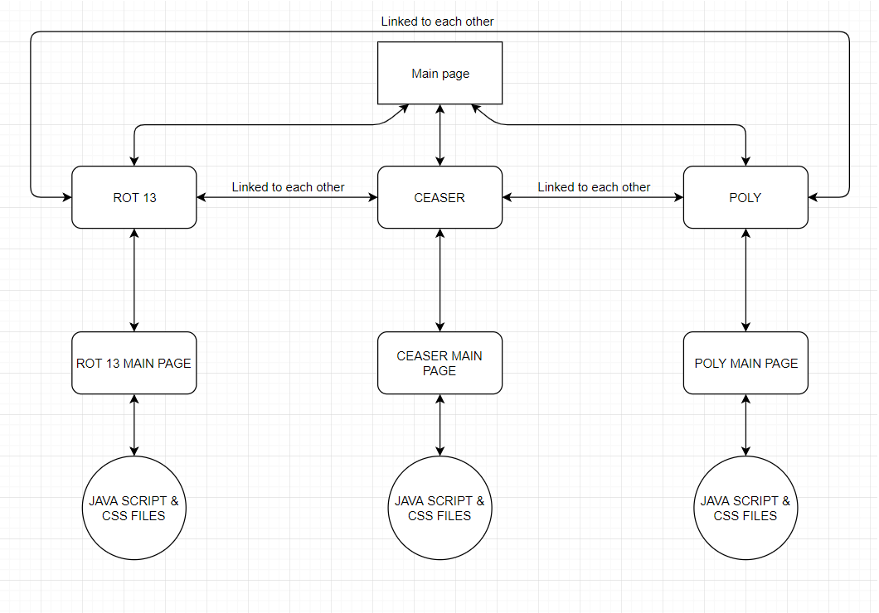

**Implementation**

After making a sketch of my website as shown in diagram 1.0. On the web home page as shown in screenshot (2.0) a brief intro of cryptography has been added on top along with the small video tutorial about how cipher works. This website has four boxes which describes three ciphers with same logo and a GitHub with different logo. The main three ciphers are Ceaser page (2.1), Rot page (2.2) and Vigenere page (2.3). All three boxes are linked with each other and the forth box contains a hyper link to my GitHub repository. Every box leads to its page for example. If a user clicks on ceaser box it will lead to the page which has a small description followed by the two text area boxes, one is for the user to input any type of text and second box will give them an encoded text. If you enter into any box by mistake or for any use user can go back to the home page by simply clicking home icon that will now appear along with boxes. The layout is same for all three ciphers except the main home page. However, the GitHub repository is completely different from all other boxes for example if a user enter the GitHub they don’t have any option or logo to go back to the web home page. They can only go to the web home page by clicking backspace button on their keyboard. Moreover, the copyrights has also been added on the bottom of every page except GitHub to make the website trustworthy and secure for the users. It was difficult for me to align all boxes with same size to make it look smooth and professional. All the boxes have different color with shadow effect and it also shrinks when the cursor is on it showing a title of the box. However, every page has a different code depending on its work requirement. Background music has also been added for all three cipher web pages. Following are the screenshots which shows my front end web page:

Home Page: 2.0

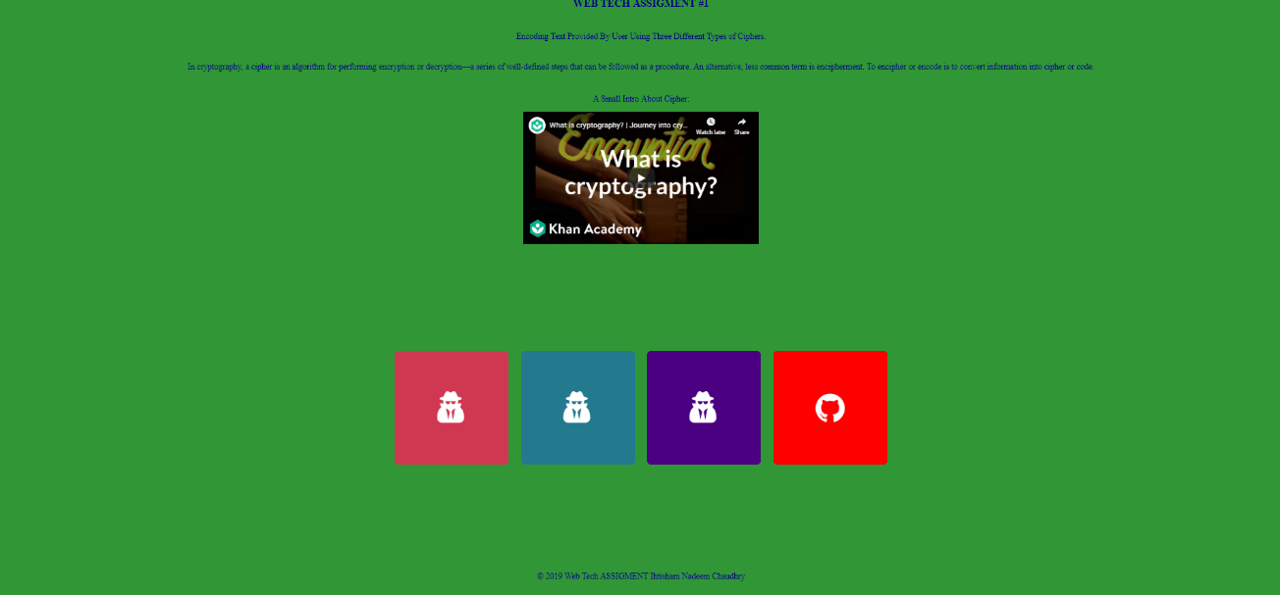

Ceaser Page: 2.1

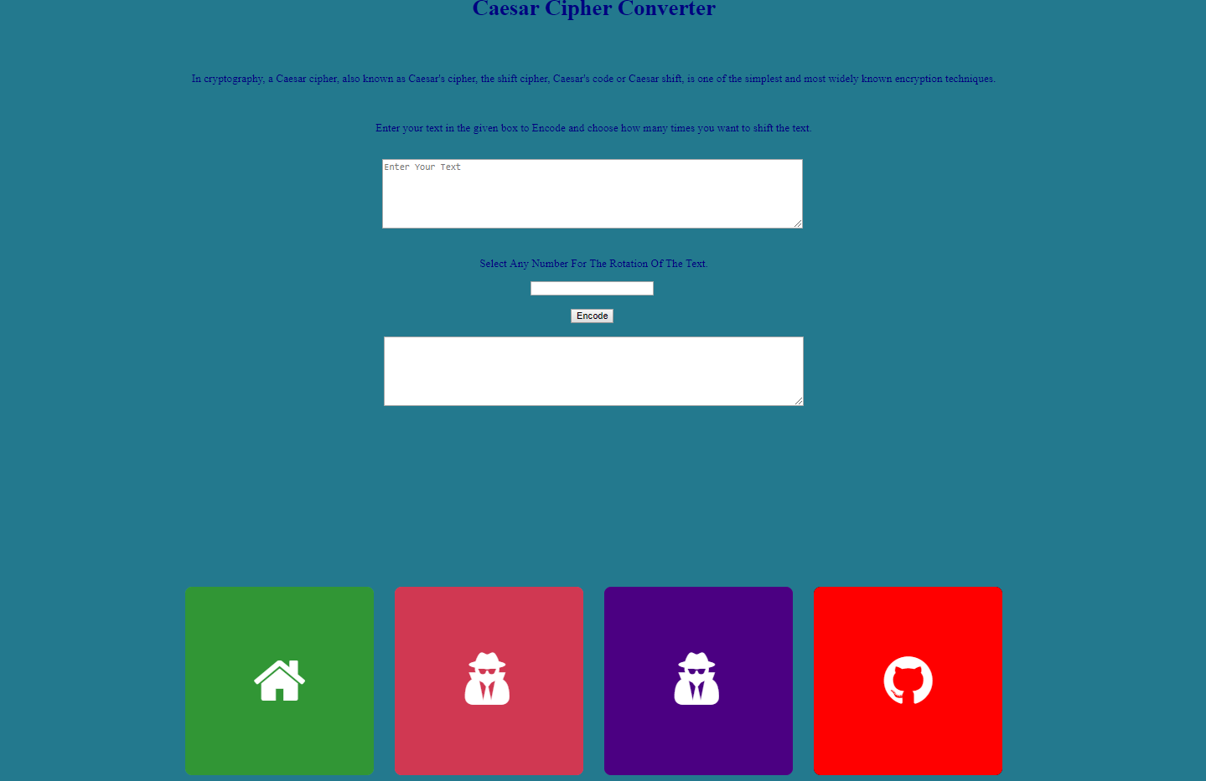

Rot 13 Page: 2.2

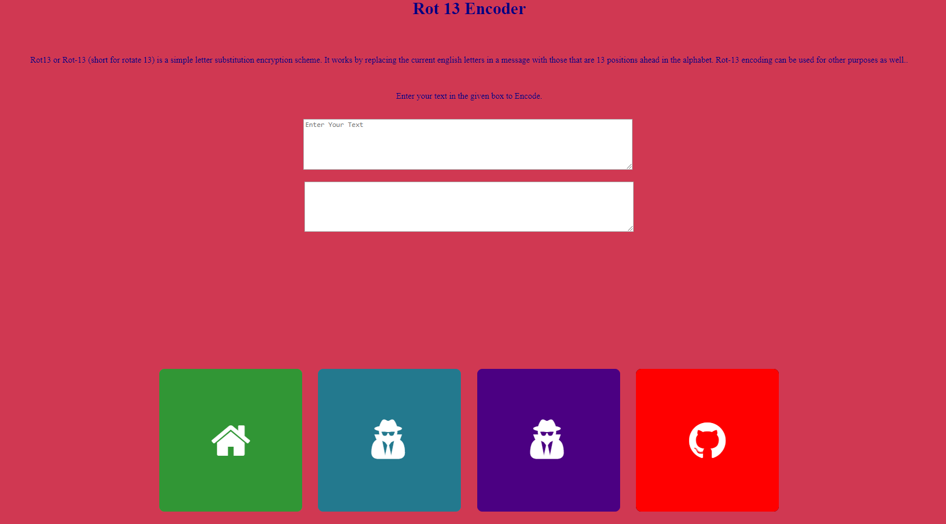

Vigenere page: 2.3

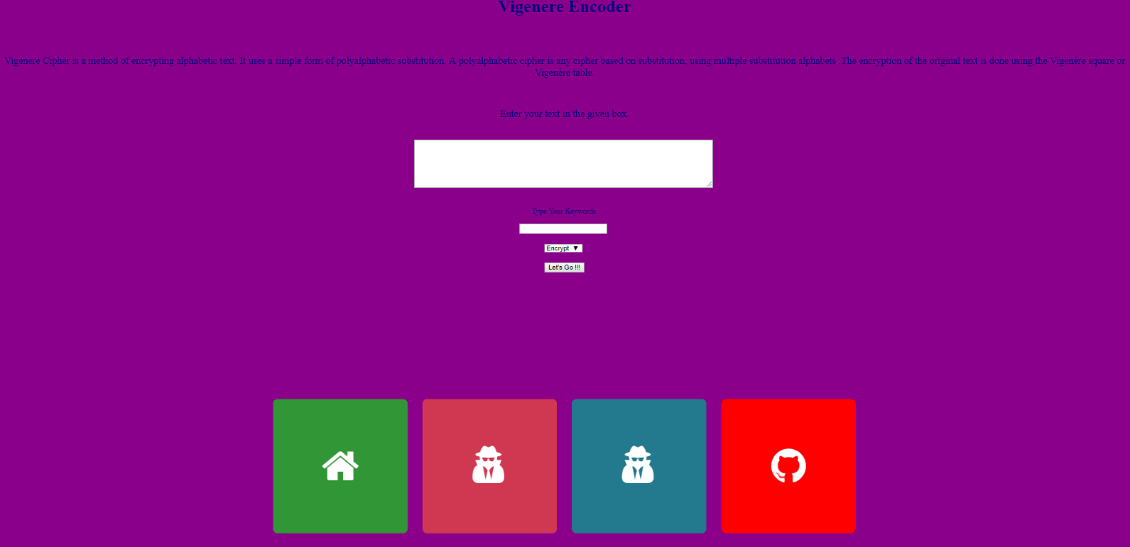

**Critical evaluation of my implementation**

Requirements for this project was to make a web. Which has three types of ciphers and it takes text from a user depending on their selection, which ciphers does user wants to use for encoding their text. Users can also decodes the text by using the same cipher.

I only managed to make a web page which shows a short description about ciphers. User can select one of the cipher from the home page and write the text into a given box, after clicking convert button its goes back to backend HTML in which JavaScript will get executed and user can see the encoded text in the below table.

My web page can be improved in many ways. I have used three type of ciphers in which only one cipher Vigenere can encode and decode the typed text. However, the other two ciphers can only encode the given text. My HTML codes can be written in more efficient and organized way instead of randomly writing the codes and confusing myself and others who can handle this web on my behalf. The web page can be improved my adding more information about how it works and what are its uses. I had also added a background music but it can be improved by giving user an option to pause or mute the music if they feel it’s annoying or disturbing to their work. Moreover, the different logos can be originated for all three ciphers to make it creative and professional web page.

**Personal Evaluation**

If one is looking into the demonstration of the project it seems easy. When I started and went deep into the project with JavaScript it start to look unstable and quite difficult for me. However, I had to do research and study more about JavaScript. How to code and how does JavaScript works with HTML. I tried to make rot 13 cipher JavaScript but that did not responded properly as I had never used or learned JavaScript before. After facing some difficulties, I had figured it out by the help of my friend and online community GitHub, Stack Overflow etc. I got an idea about how ceaser cipher works by looking into lecture slides and some online study and luckily got it working. Once all the ciphers were on roll and started working they need to be implemented on a single web page which has been done through HTML. I faced many issues regarding “web page not found” or CSS code “not perfectly implemented” etc. Every problem was resolved by researching over the internet. I have learned many new things related HTML, CSS & JavaScript, which are highly useful in my further studies and in the field of work.

**References**

Alvaro Calsolari, ROT 13, 17th October 2017, <https://github.com/AlvaroCalsolari/rot13>